**ULTRA GAIN BOOST CONVERTER FED BLDC MOTOR FOR FCEV APPLICATIONS**

**A Major Project Report**

Submitted in partial fulfillment of the

requirements for the award of the Degree of

**BACHELOR OF TECHNOLOGY**

**IN**

**ELECTRICAL AND ELECTRONICS ENGINEERING**

*by*

|  |  |
| --- | --- |
| **G. VINAY KUMAR** | **(20P65A0222)** |
| **B. JHANSI** | **(19P61A0218)** |
| **B. VINAY KUMAR** | **(19P61A0217)** |
| **B. SANDEEP** | **(20P65A0205)** |

Under the esteemed guidance of

**Dr. B. NAGI REDDY M.Tech, Ph. D, MIEEE, MISRD**

**Associate Professor**

**DEPARTMENT OF ELECTRICAL & ELECTRONICS ENGINEERING**

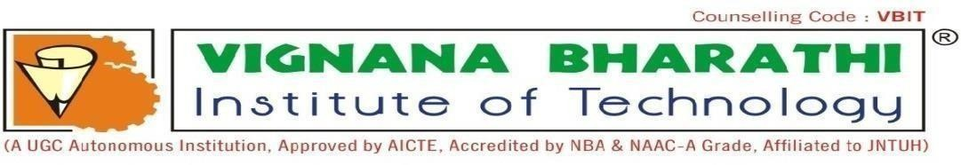

# VIGNANA BHARATHI INSTITUTE OF TECHNOLOGY

**(An Autonomous Institution, Accredited by NBA and NAAC, New Delhi)**

**Aushapur (V), Ghatkesar (M), Medchal Dist, Telangana-501301**

**2019-23**



**Aushapur (V), Ghatkesar (M), Medchal Dist, Telangana -501301**

**DEPARTMENT OF ELECTRICAL AND ELECTRONICS ENGINEERING**

# CERTIFICATE

This is to certify that major project report entitles, “**ULTRA GAIN BOOST CONVERTER FED BLDC MOTOR FOR FCEV APPLICATIONS**”, done by G. VINAY KUMAR (20P65A0222), B. JHANSI (19P61A0218), B. VINAY KUMAR (19P61A0217), B. SANDEEP (20P65A0205) submitted to the faculty of Electrical and Electronics Engineering in partial fulfillment of the requirements for the Degree of BACHELOR OF TECHNOLOGY from VBIT, Aushapur, Hyderabad.

**Project Guide Head of the Department**

**Dr. B. NAGI REDDY M.Tech,Ph. D,MIEEE,MISRD Dr.K. Neelima M.Tech, Ph. D,MISTE**

**Associate Professor Professor & HoD**

**EXTERNAL EXAMINER**



**Aushapur (v), Ghatkesar (m), Medchal Dist., Telangana -501301**

**DEPARTMENT OF ELECTRICAL AND ELECTRONICS ENGINEERING**

# DECLARATION

We hereby declare that the project entitled “**ULTRA GAIN BOOST CONVERTER FED BLDC MOTOR FOR FCEV APPLICATIONS**” is carried out during 2019-2023 in a partial fulfillment for the award of **Bachelor of Technology** Degree in Electrical and Electronics Engineering. We have not submitted this dissertation to any other University or Organization for the award of any other Degree.

*by*

|  |  |
| --- | --- |
| **G. VINAY KUMAR** | **(20P65A0222)** |
| **B. JHANSI** | **(19P61A0218)** |
| **B. VINAY KUMAR** | **(19P61A0217)** |
| **B. SANDEEP** | **(20P65A0205)** |